**Alexander (Skunder) Boghossian (1937-2003)**

Alexander Boghossian, better known as Skunder, was one of the most prominent figures of African Modernism. Born in Addis Ababa in Ethiopia in 1937 to Ethiopian-Armenian parents, Boghossian won a government scholarship to study in Europe at age seventeen. He studied in London at St. Martin’s School, the Slade, and Central School between 1955 and 1957. He then moved to Paris in 1957 and continued his training at L’École National Supériore des Beaux Arts and L’Académie de la Grande Chumière until 1966. Boghossian became part of the artistic and intellectual fabric of Paris during the late 1950s and 1960s, meeting influential figures in the Pan African and Négritude movements, including philosopher Sheikh Anta Diop, Léopold Senghor, and the Congolese poet Tchikaya U’Tamsi. In particular, Aimé Césaire’s poetry greatly influenced and inspired Boghossian’s vision. Artistically, Boghossian associated with the Surrealist movement and artists including Wilfredo Lam, Paul Klee, Andre Breton, Max Ernst, Gerard Sokoto, and George Braque.

During his years in Paris, Boghossian began to receive international exposure and recognition. In 1959, he was invited to participate in the Second Congress of Negro Artists and Writers in Rome alongside Brazilian artist Gerard Sekoto and Senegal artist Ibrahim Papa-Taal, who also studied at L’École des Beaux Arts. Boghossian became the first Ethiopian artist to be honoured by both the Musée d’Art Modern in Paris in 1963 and the Museum of Modern Art in New York in 1965. It was also through his Parisian network that he became friends with African art collectors Medelaine Rousseux and Merton Simpson, who in turn introduced him to important African American artists, including Jacob Lawrence. In 1961, Boghossian took part in the first Contemporary African Art exhibition held in the United States by invitation of the Harmon Foundation (a leading patron of African American art) during the social upheaval which resulted in the Harlem race riots in 1964.

Boghossian then moved to Addis Ababa in 1966 to start a family and for the next three years, he became an art teacher at the Addis Ababa School of Fine Arts. Together with artists Gebre Kristos Desta, Theodros Tsege Marqos, Endale Haile Selassie, and Zerihun Yetmgeta, Boghossian played an instrumental role in teaching and inspiring a new generation of Ethiopian artists to explore new possibilities through art. This sparked a time of great artistic, musical, and intellectual productivity, known as the Addis Spring Renaissance.

In particular, Desta and Boghossian emerged as the most progressive artists and teachers at the Addis Ababa Fine Arts School; they advocated abstract expressionism and had a lasting impact not only on Ethiopian Modern art development, but the historiography of African Modernism. Together with other African Modernists, Boghossian and Desta reclaimed Modern art as being part of a shared cultural history, drawing from local and European techniques and pan-African ideas. Their cultural heritage would give new expression and vitality to their work and a political dimension to the role of the artist. They recognized the pivotal role African art played in inspiring a new generation of European art movements during the turn of the nineteenth and early twentieth centuries: primitivism and Cubism. Boghossian highlights this point in an interview with Valerie Cassel,: “For my generation, the Négritude Movement and Contemporary African Arts Movement were cultural movements linked to the political and social issues prevalent at the time. We were all coming together to listen to our stories and to find a commonality in ourselves and in our struggles. We found this in Paris. Paris was central to the movement.”

Before the Derg military regime took a hold of Ethiopia in 1974, resulting in artistic restrictions and propaganda based art, Boghossian left Ethiopia by invitation to teach at the Atlanta Center for Black Art. He later became artist in residence at Atlanta University, which was at the forefront of the Civil Rights Movement and Black Power. Boghossian embraced the Civil Rights Movement through his work, which he saw as an extension of his political commitment to justice, equality, and liberty. In recognition of his achievements both as a teacher and an artist, Boghossian took up an arts residency at Howard University in 1972, where he became Assistant Professor in 1974 and Associate Professor in 1978, ending his impressive teaching career in 2001.

Boghossian used abstract expressionism and layers of complex imagery rooted in his life experiences. Afrocentric, pan-African ideals were expressed through the use of mythological images and masks from diverse African countries. Boghossian drew from his Ethiopian and Armenian roots through the use of Ethiopian icons, biblical stories, Coptic and Aksum designs, richly interwoven with artistic symbols from Oromo and Konso carvings, Adere embroidery, *brana* healing scrolls, patterns from Tiletes, and *mesobos* (traditional food plates and tables). Boghossian was also an experimenter, using local and traditional materials and methods from Ethiopia, such as bark cloth, goat skin, natural earth colours combined with European techniques and materials. A visionary, innovator and pioneer, Alexander ‘Skunder’ Boghossian dedicated his life to his art and has become one of the fathers of African Modernism today.

References and Further Reading

Lunn, F. and Havell, J. (1995), *Seven Stories: about modern art in Africa*, Paris: Flammarion.

Salah, M. H. (1993), *Creative Impulses: four African artists: Skunder Boghossian, Rashid Diab, Mohammed Omer Khalil, Amir Nour,* New York: Cornell University.

Cassel, V. (1993), *Convergence: Image and Dialogue, Conversations with Alexander ‘Skunder’ Boghossian* in Third Text, 7:23 (Summer 1993), pp53-68. <http://dx.doi.org/10.1080/09528829308576415>

Nagy, R. M. (2007), *Continuity and Change: Three Generations of Ethiopian Artists*, in African Arts, Vol. 40, No. 2 (Summer, 2007), pp. 70-85, Los Angeles: UCLA James S. Coleman African Studies Center.

<http://www.jstor.org/stable/20447829>

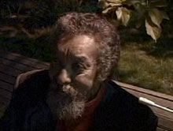

<http://africa.si.edu/exhibits/passages/skunder-modemframe.html>

Ethiopian Passages: Dialogues in the Diaspora, curator Elizabeth Harney

on paper  
66 x 59 cm. (26 x 20 in.)  
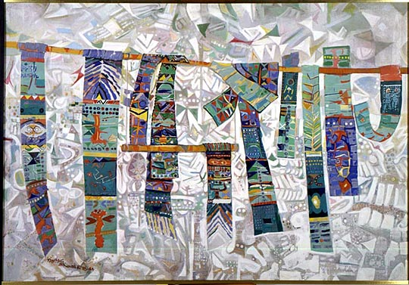

Thttp://www.nmafa.si.edu/exhibits/encounters/images/SpringScroll.jpg

Title: Spring Scrolls

1983-1984

Acrylic on Canvas

128x 182.2 cm (50 3/8 x 71 4/4 in.)

National Museum of African Art, Washington DC

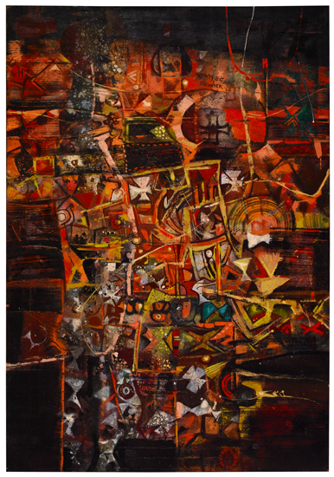

http://catalogue.swanngalleries.com//full//344/609344.jpg

Title: *Axum.*Oil on canvas, 1967. 1150x800 mm; 45x31 1/2 inches. Signed and dated in oil, upper right.   
  
Provenance: the artist; private Maryland collection; thence by descent to the current owner.   
  
Exhibited: African Art Today: Four Major Artists, The African American Institute, New York, May 14 - August 31, 1974; Contemporary African Arts, The American Museum of Natural History, New York, May - August 1975.